REPORT ON VISIT TO RWANDA
Duration: 19th to 22nd of May, 2026
Introduction
This report outlines the activities and outcomes of a three-day trip to Rwanda focused on establishing the status of mainstreaming the guidelines for animal welfare in development cooperation and enhancing collaborations with government. The trip included meetings with key stakeholders, attending a Tot training sessions, and strategic discussions aimed at future collaboration following the approval of new legislation.
Day 1: Meetings with Key Stakeholders
The first day of the trip was dedicated to engaging with ministry of agriculture (MINAGRI) and Rwanda Agricultural board (RAB) officials in Rwanda. The following meetings were held:
Dr. Fabris (HoD- RAB): Discussed current agricultural policies and initiatives related to animal resources. Major highlight was that following the regular engagement with RAWO, the Animal resource law was revised, approved by cabinet and will be gazetted by mid this year. RAWO, continues to be a pioneer and key stakeholder in animal welfare within Rwanda.
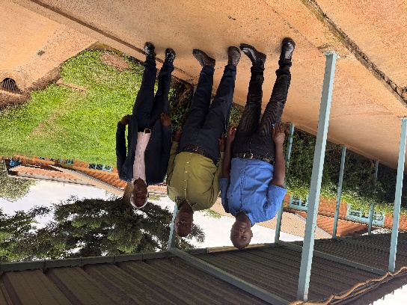

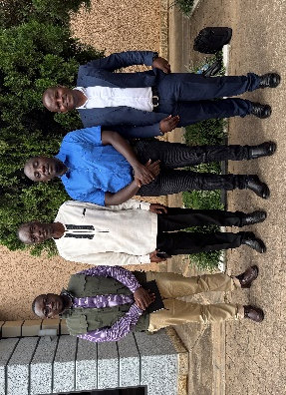
Chair of Rwanda Council of Veterinary Doctors (RCVD): Explored the role of veterinary professionals in ensuring animal health and welfare. Rwanda has over 6000 animal health professionals whereby 88% work in private sector and 12% are in the public sector. So, the former are the ones involved in the Veterinary Sanitary Mandate that RAWO is targeting in the current project. Therefor RAWO’s impact through this ToT project will benefit a large group of the country’s workforce in the animal health sector.

Director General of Animal Resources at the MINAGRI:
Discussed the newly approved animal resource law that includes four ministerial orders of which one focuses on animal welfare. This has been achieved through RAWO’s constant engagement with the ministry and therefor during the drafting of this law, the ministry benchmarked the guidelines introduced by RAWO. We also discussed the potential for joint implementation of the ministerial order on animal welfare through creation of awareness and joint development of instruments for its effectiveness utilisation and benefit to animals on farms and in development cooperation projects.
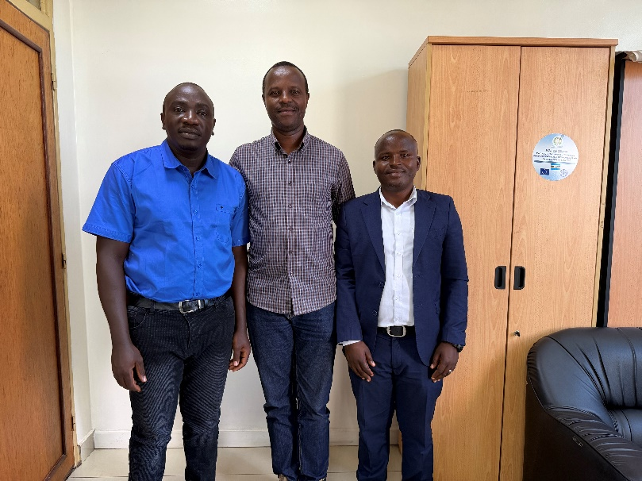

Day 2: Training for Animal Health Practitioners
On the second day, attendance at a specialized training session for animal health practitioners was the highlight. This ToT training was conducted for the Veterinary Sanitary Mandate animal health practitioners of Rwanda, included both theoretical and practical components:
- Theoretical Sessions: Covered essential topics in animal welfare, antibiotic resistance, one health and management practices.
- Field Practicals: Provided hands-on experience in clinical examination, diagnosing and treating common animal health issues in local settings.
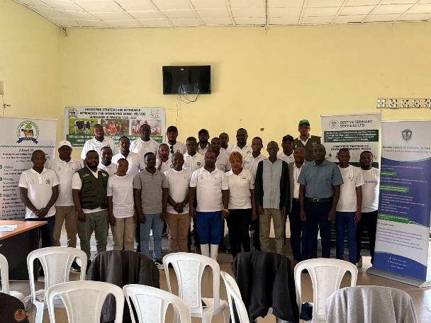

Day 3: Meeting with the Permanent Secretary of MINAGRI
The final day included a strategic meeting with the Permanent Secretary of the Ministry of Agriculture. The discussion focused on the following: Reviewing the progress of the new animal resource law, which is expected to be gazetted soon (Mid 2026). Identifying opportunities for collaboration aimed at leveraging resources for animal health initiatives. The meeting emphasized the importance of aligning efforts with government objectives to optimize the impact of future projects in the animal resources sector. He also pledged support for RAWO and its initiatives.
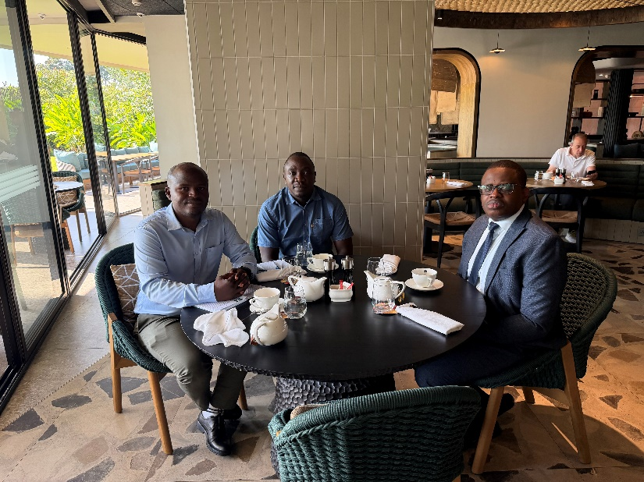

Conclusion
The three-day trip to Rwanda was successful in fostering relationships with key stakeholders in the agricultural sector and enhancing the understanding of progress with mainstreaming the guidelines for animal welfare in development cooperation. RAWO’s previous projects were fundamental in creating awareness about animal welfare among government officials and therefor leading to revision of the animal resource law with full consideration of animal welfare. The anticipated approval of the new animal resource law will serve as a foundation for ongoing collaboration in developing implementation instruments and awareness creation among key stakeholder (including IDOs) about the requirements of the new law.

